Application of virtual labs in the analysis of automatic control systems

(Case Study: Boiler Control Systems)

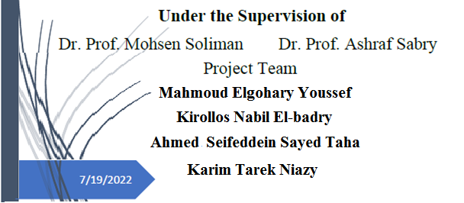

Abstract

